**Table 1.** Tree species used in fenced and unfenced seedling plots with corresponding AICc values for null models, which does not include fencing treatment, and treatment models, which does include fencing treatment, and the difference between each. AICc values greater than 2 indicated that for four of the six species (highlighted in gray), fencing treatment contributed to the best fit model for seedling survival.

|  |  |  |  |
| --- | --- | --- | --- |
|  | **Model AICc value** | | |
| **Seedling species** | **null** | **treatment** | **difference** |
| *Carica papaya* | 155.81 | 121.13 | 34.68 |
| *Psychotria mariana* | 100.51 | 78.39 | 22.12 |
| *Morinda citrifolia* | 114.55 | 105.27 | 9.28 |
| *Premna serratifolia* | 94.17 | 86.4 | 7.77 |
| *Aglaia mariannensis* | 79.36 | 79.88 | -0.52 |
| *Ochrosia oppositifolia* | 46.22 | 48.94 | -2.72 |

**Table 2.** List and counts of species germinated in from deer scats (n=20) and pig scats (n=31). Two native species (highlighted in gray) occurred in large numbers in pig scats and a small number of non-native species (not highlighted) appeared in a few of both pig and deer scats.

|  |  |  |  |  |
| --- | --- | --- | --- | --- |
|  | **Deer** |  | **Pig** |  |
| **Species** | **Seedling count** | **In number of scats** | **Seedling count** | **In number of scats** |
| *Morinda citrifolia* | 0 | 0 | 1119 | 20 |
| *Ficus prolixa* | 0 | 0 | 247 | 3 |
| *Carica papaya* | 1 | 1 | 266 | 16 |
| *Vitex parviflora* | 1 | 1 | 0 | 0 |
| *Passiflora suberosa* | 8 | 1 | 13 | 3 |
| *Mikania micrantha* | 1 | 1 | 0 | 0 |
| *Coccinia grandis* | 0 | 0 | 3 | 3 |
| *Chromolaena odorata* | 0 | 0 | 1 | 1 |
| *Leucaena leucocephala* | 0 | 0 | 1 | 1 |
| unknown | 2 | 1 | 8 | 4 |
| Total | 13 |  | 1658 |  |

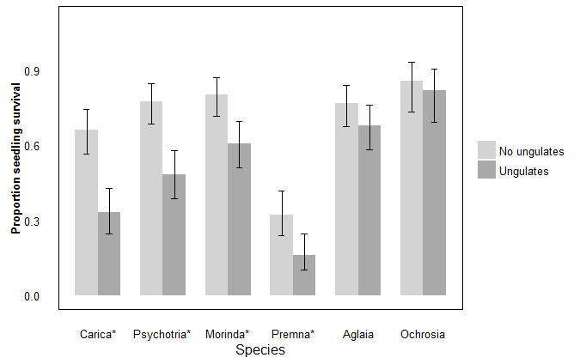

**Figure 1.** A higher proportion of seedlings survived in fenced versus unfenced plots for four out of six forest species. For *Carica papaya*, *Morinda citrifolia*, *Psychotria mariana*, and *Premna obtusifolia*, all indicated with *, the best fit model for proportion alive included treatment, and in all cases, proportion alive inside fenced plots with “No ungulates” was higher than outside fenced plots with “Ungulates.” For *Aglaia mariannensis* and *Ochrosia oppositifolia* seedlings, treatment did not contribute to the best fit model explaining proportion of seedlings alive, and proportion of seedlings alive did not differ significantly due to treatment.

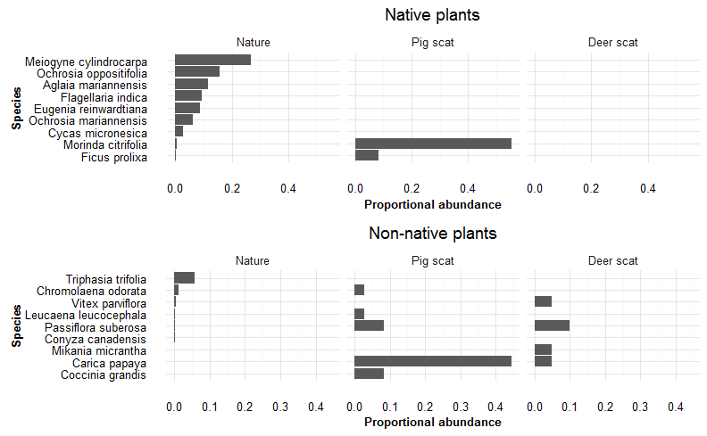

**Figure 2.** Proportional abundance of species in nature, with most abundant at the top, are shown in the left most panel of each bar graph for native and non-native species, in the top and bottom panels, respectively. The top panel shows the most abundant native fruiting species in nature in, based on vegetation surveys, with *Meiogyne* *cylindrocarpa* through *Cycas* *micronesica* being the seven most abundant species counted on transects. *Morinda* *citrifolia* and *Ficus* *prolixa*, while not part of the most abundant species on vegetation transects, were two native species that germinated from pig scats in much higher proportions than expected given their abundance in nature. Non-native species, especially *Carica papaya* and *Coccinia grandis*, also germinated in a relatively high proportion of scats, given their relatively low availability in nature. The two right-hand panels show that no native species germinated from deer scats. Instead, a small number of non-native species germinated in just a few deer scats.

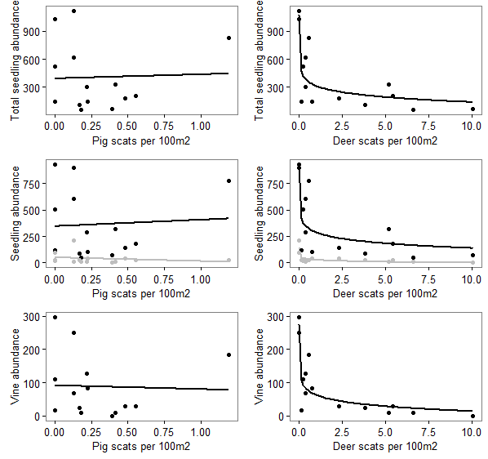

**Figure 3.** In the left-hand column, regression analysis between abundance of pig scats (relative index for population abundance) showed no relationship with total seedling abundance, non-native nor native seedling abundance (middle row, with black line for native and gray line for non-native), nor vine abundance per survey site in Guam. In the right hand column, abundance of deer scats (relative index for population abundance) show strong negative loglinear relationships to total seedling abundance (r2 = 0.710), native seedling abundance (r2 = 0.647), non-native seedling abundance (r2 = 0.696), and to vine abundance (r2 = 0.751).